DESIGNING PROFESSIONAL BUSINESS CARDS.

## INTRODUCATION:

**1.1 Include Only What's Most Important**

Include enough information to pique the interest of recipients and make the business card memorable. It's tempting to reduce the font size and include every type of job you've done, testimonials, and more, but this leads to information overload and nothing memorable. Skip the kitchen sink and be selective about the information you include.

* Name
* Job title
* Email address
* Phone number
* Website address
* Three or four social media handles

You may also want to add a slogan, a QR code, and an image or headshot.

## PURPOSE:

**They say you never get a second chance to make a first impression, and nowhere does this ring more true than in the world of networking.**

**Business cards have been around for centuries – in fact, the origins of the humble 85mm x 55mm rectangle of card can be traced back to the 15th century, where the upper class would use them as calling cards to announce an intention to meet another individual.**

**In 17th century London before street numbers were in existence, came “Trade Cards”, small cards informing people where the business was and what services it offered – if one was signed, it was considered legally binding.**

**Fast forward to 2018 and thankfully handing out your business card is far from the etiquette minefield it was centuries ago.**

**So let’s take a look and see why your business needs a business card.**

## PROBLEM DEFINITATION &DESIGNING THINKING:

### EMPATHY MAP:

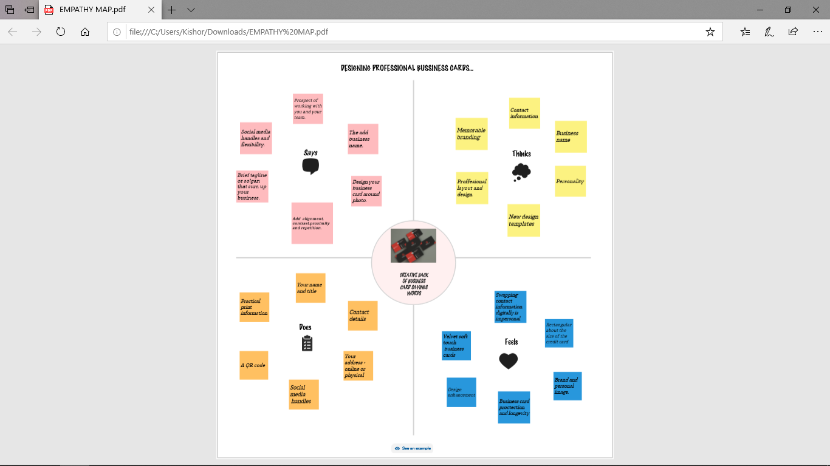

### IDEATION&BRIANDTORMING:

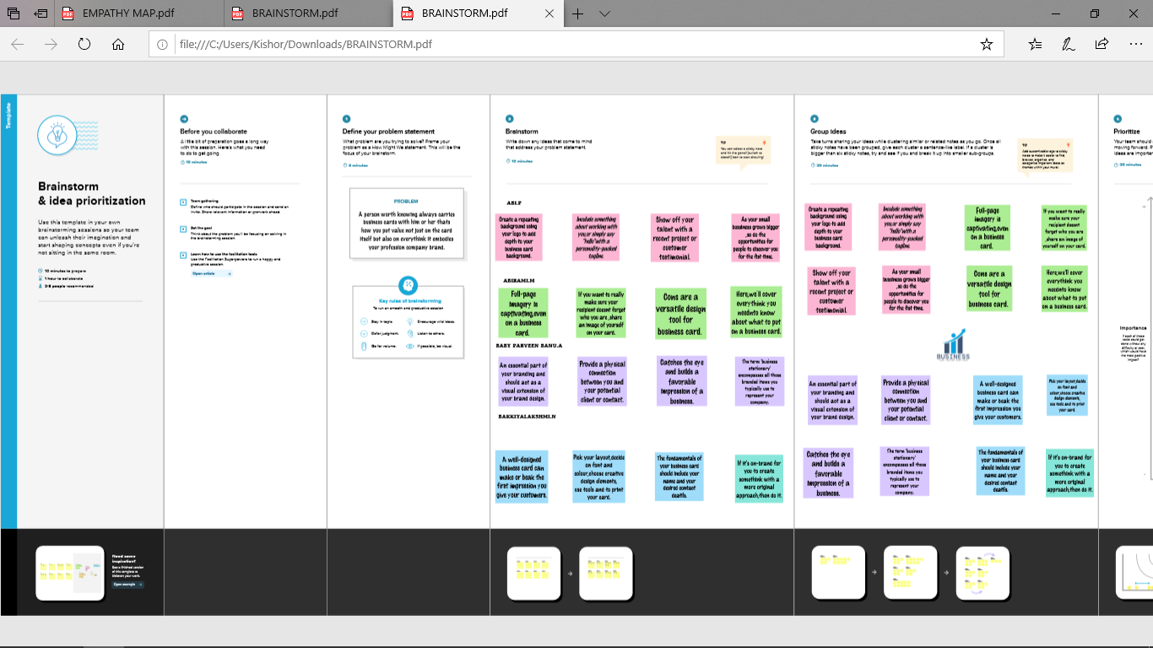

### 3.RESULT:

## 

## ADVANTAGES AND DISADVANTAGES:

A business card is a quick and practical solution for the customer to know at once all the key business information you want him to know. What your business is like, the name of the contact person, e-mail, your phone ... all this relevant information fits in the palm of your hand! & Nbsp;

Take a look at some reasons you might opt out of using business cards.

Business cards might be susceptible to wear and tear. Laminating cards might help, but they are still subject to the elements. And, recipients could easily lose cards.

Many people don’t want to receive business cards.

## APPLICATION:

Hosting key business information, such as your website, email and phone number, a business card encourages people to contact you, visit your business (online or in real life) and learn more about you. Another way to encourage customers to engage — and hold on to your business card — is by adding an incentive. Maybe it’s a free consultation, or a 10% off coupon when they make their first online order. Handing someone a business card can be the first step in forging a relationship…and strong relationships are critical to business success.

## CONCLUSION:

### digital business cards offer a great way to save time and money while also helping to protect the environment. With their convenience and cost-effectiveness, digital business cards are becoming increasingly popular among businesses and individuals.